Most fire extinguishers operate using the following P.A.S.S. technique:
- PULL... Pull the pin. This will also break the tamper seal.
- AIM... Aim low, pointing the extinguisher nozzle (or its horn or hose) at the base of the fire.
- NOTE: Do not touch the plastic discharge horn on CO2 extinguishers, it gets very cold and may damage skin.
- SQUEEZE... Squeeze the handle to release the extinguishing agent.
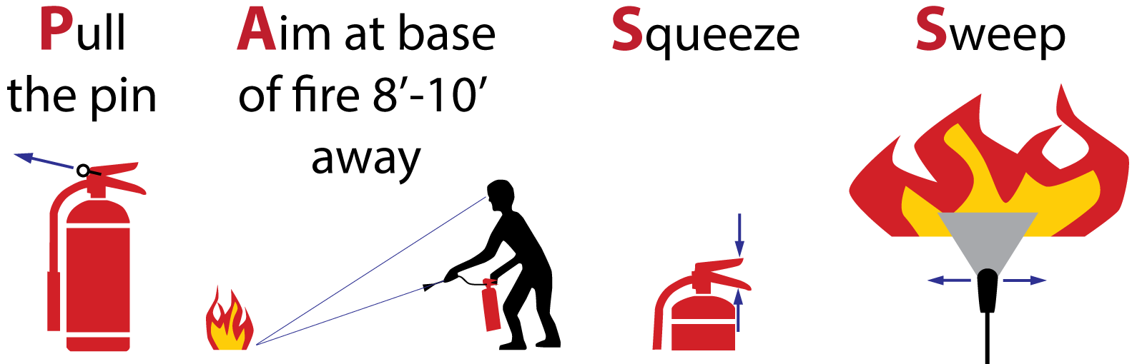
- SWEEP... Sweep from side to side at the base of the fire until it appears to be out. Watch the area. If the fire re-ignites, repeat steps 2 - 4.
If you have the slightest doubt about your ability to fight a fire....EVACUATE IMMEDIATELY!

